**Lesson00 Overview to Azure**

**Notes:-**

**1-Azure is cloud platform that can host your application and use various services such as physical server / VM / storage / SQL server , etc..**

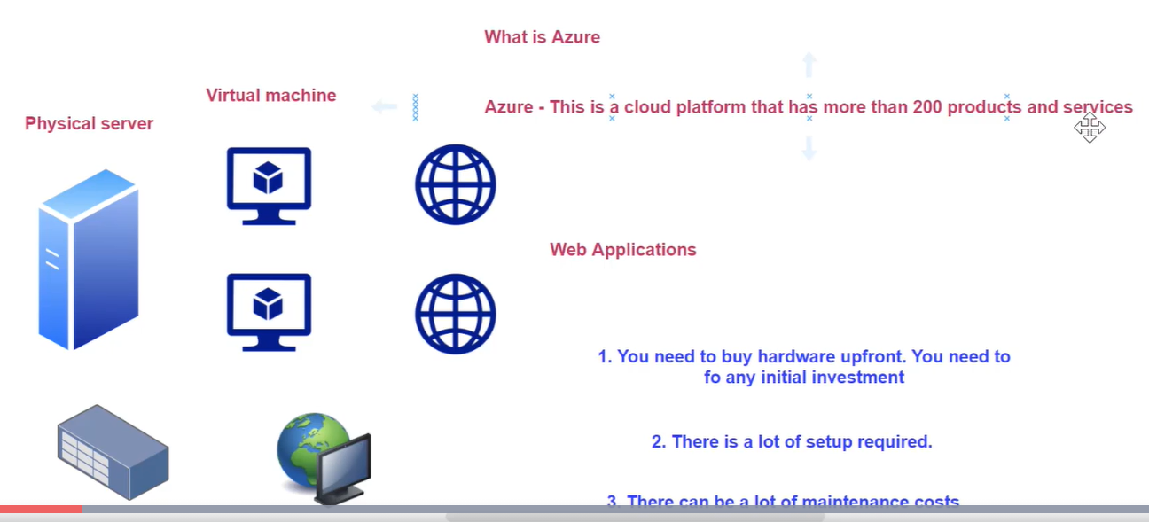

**2-Advantage of using Azure VM (Pay as you go)**

**(All the resources is controlled by Azure, this is called Platform as service)**

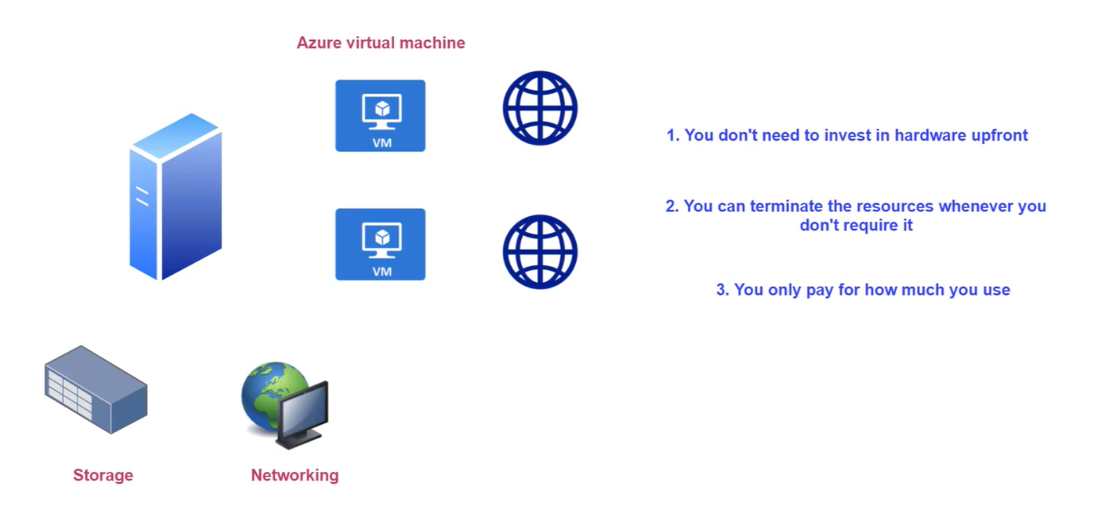

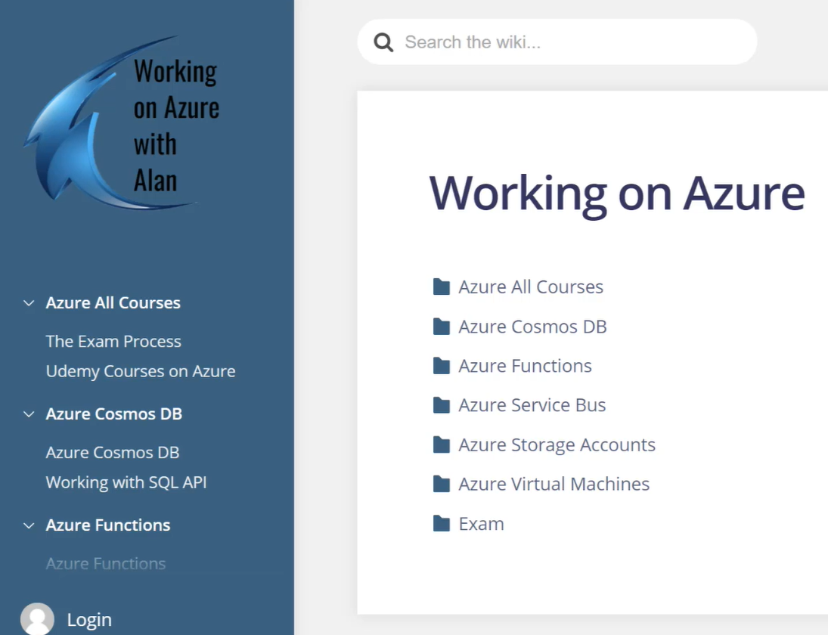

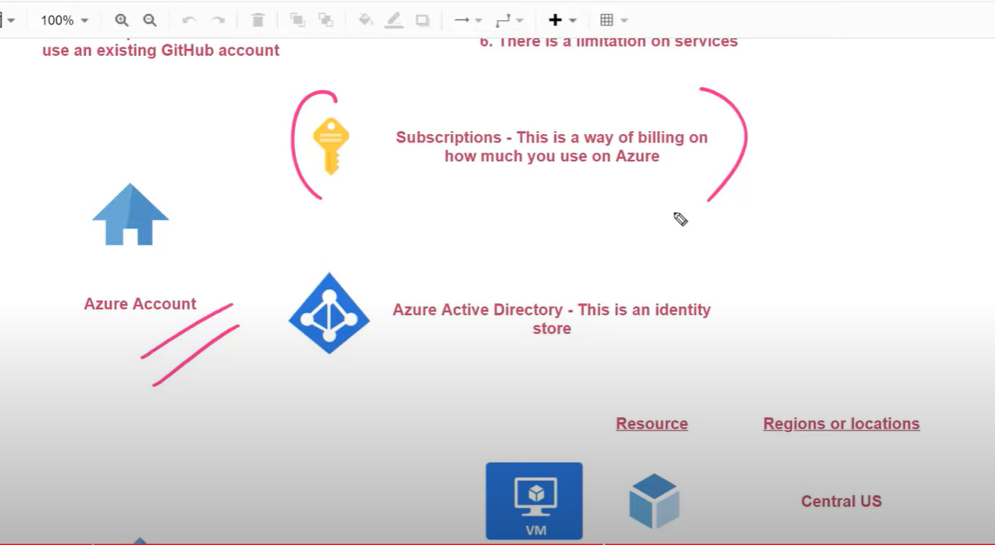

Azure subscription: where this is the way to group all azure resource groups and used for the billing account

Azure Active directory: this is an identity store for azure

Azure subscript > Azure resource groups > Azure resources (mapped with regions)

